Ingredients for 2 people:
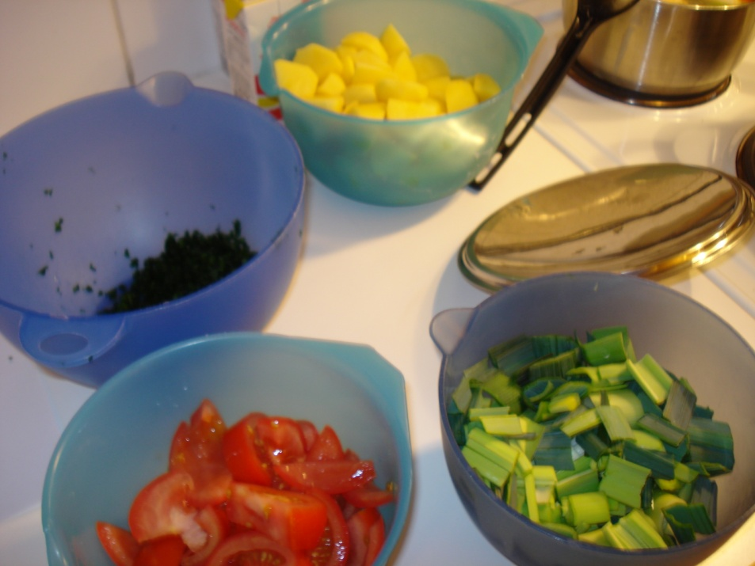
2 middle size potatoes.
1 dl green leek
1 tomatoe
150 g fish
1 table spoon lemon juice
1 ½ - 2 dl water
3 white pepper balls
1 spoon parsley
Cream
Paprikapulver
Method:
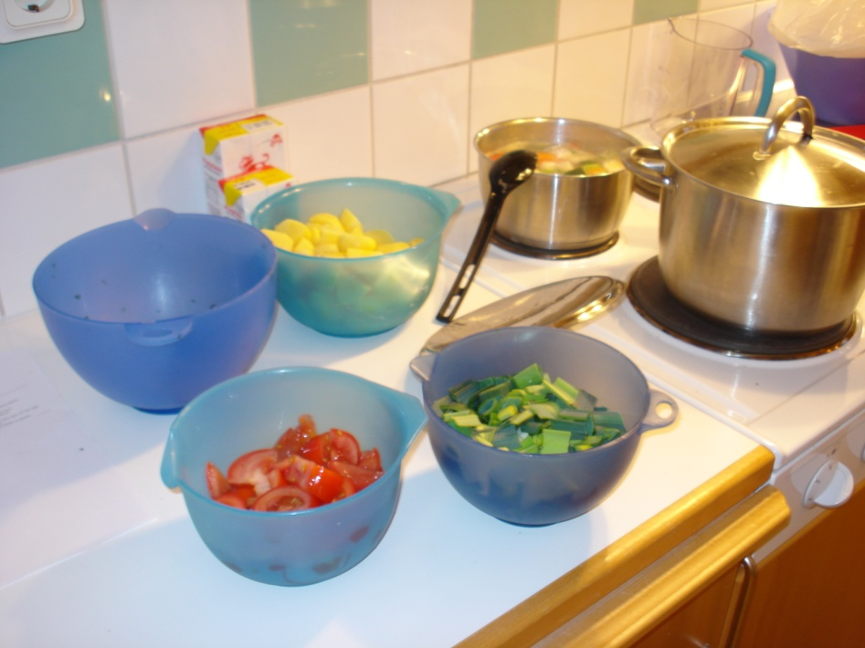
  
Peel the potatoes and cut them into dices.
Rinse the tomatoes and cut them into pieces.
Rinse and cut the green leek into pieces.
Cut the fish into pieces and press the lemon juice over the fish.
  




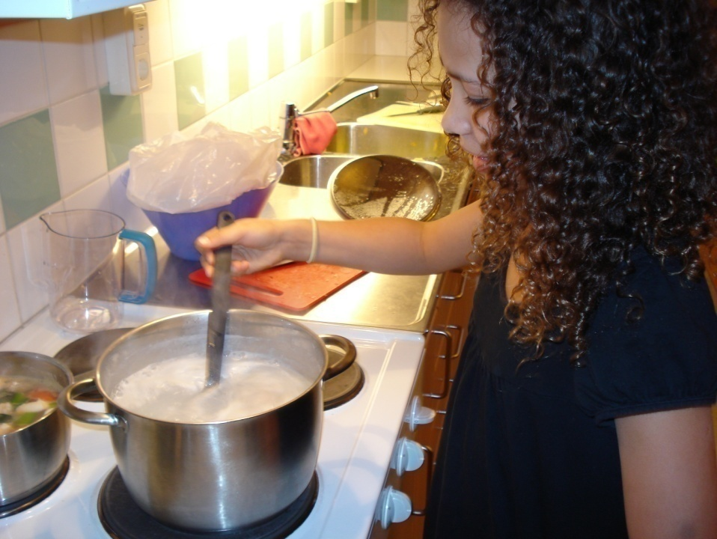
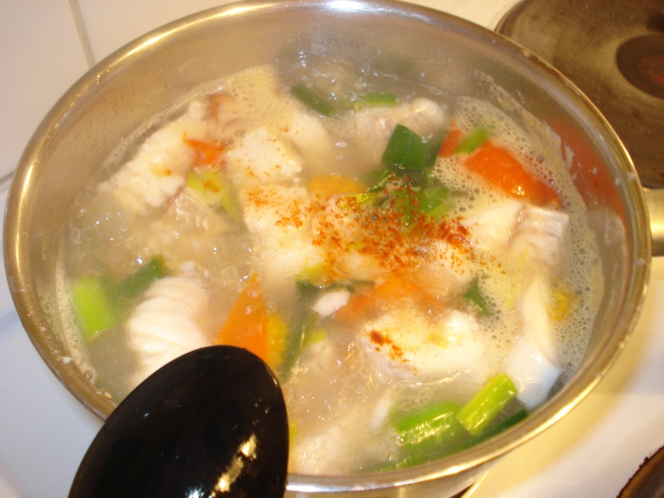

Let the soup boil for 10 minutes.
The fish shall be white and the vegetables shall be soft.
Add cream.




Pour the salt and the peppar into the boiling water.
Add the fish, the potatoes, the green leek and the tomatoes.




Let the soup boil for 10 minutes.
The fish shall be white and the vegetables shall be soft.
Add cream.




Pour the salt and the peppar into the boiling water.
Add the fish, the potatoes, the green leek and the tomatoes.



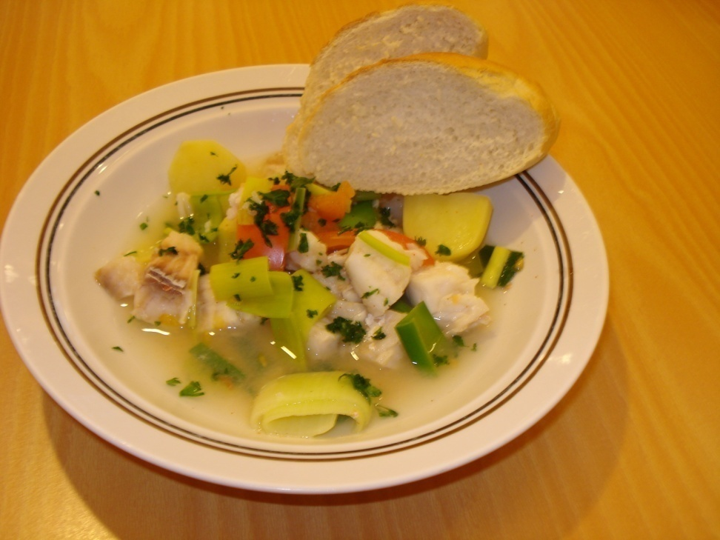
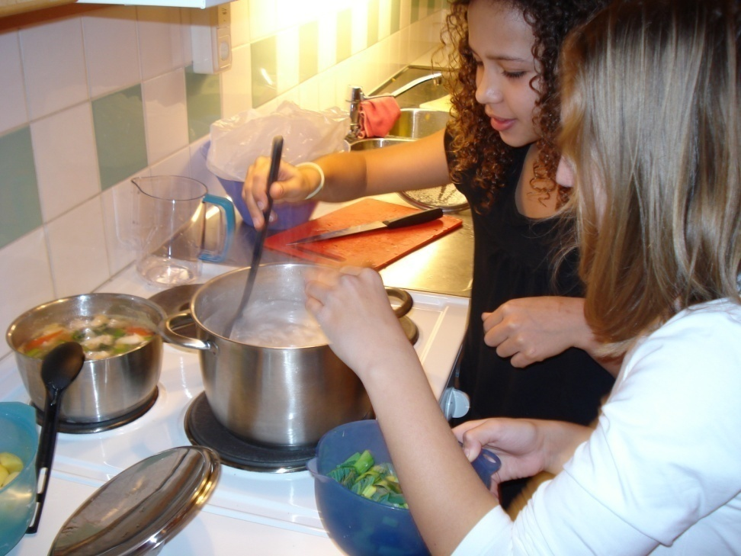

We made 2 soups, one with cream and one without cream, because some of us are allergic to cream. We are an allergic class.



Put the herbs on the soup and it’s ready to serve!!



Varsågod!!!
(Enjoy!)


