Ingredients for 32 small breads:

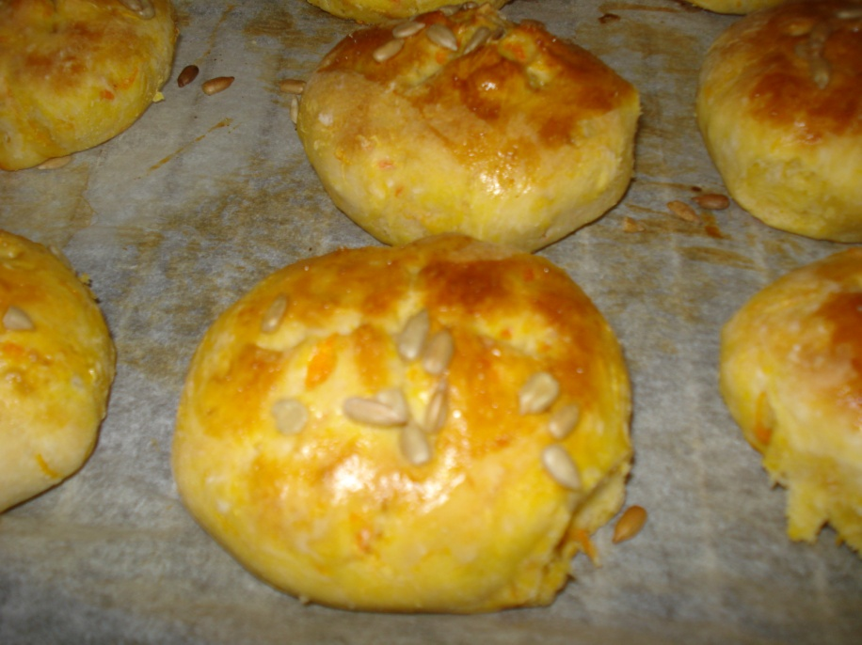50 g yeast

4 tablespoons of margarine

5 dl milk or water

1 teaspoon of salt

1 tablespoon of sugar

1,4 litre of flour

Choose one of the fillings:

1. 4-5 dl grated carrots

3-4 dl sunflower seeds

1. 6 peeled tomatoes

3 tablespoons of thyme

1. 3-4 dl lingonberry jam

Method:

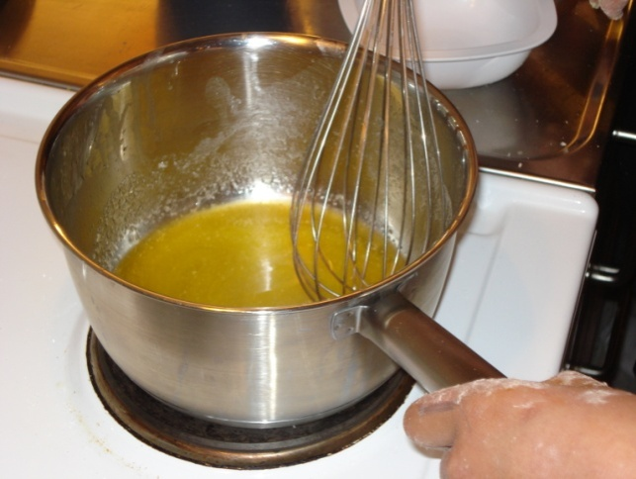

  

Crumble the yeast and melt margarine until 37 degrees ( luke warm).

Mix the yeast with the margarine and pour this into a bowl.

  

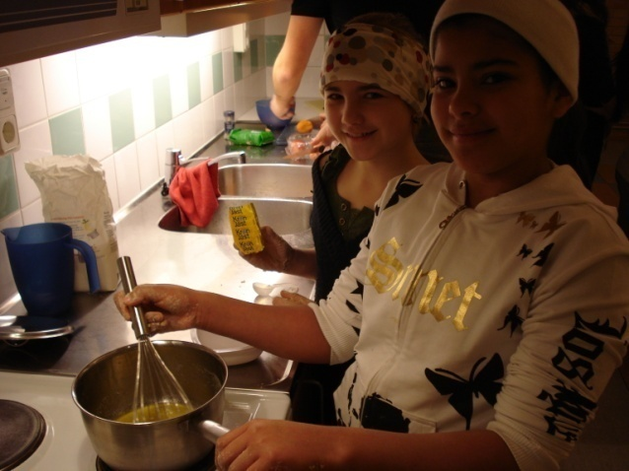

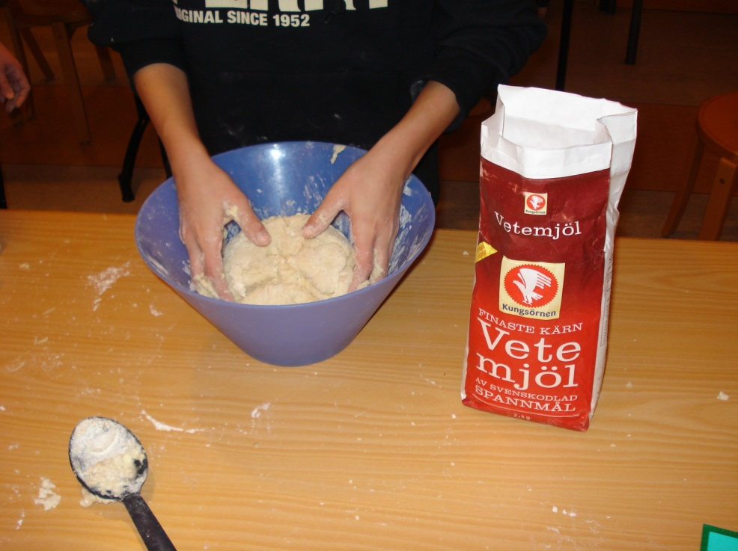



Add the remaining ingredients and knead it to a ready dough.





Pour the salt and the peppar into the boiling water.

Add the fish, the potatoes, the green leek and the

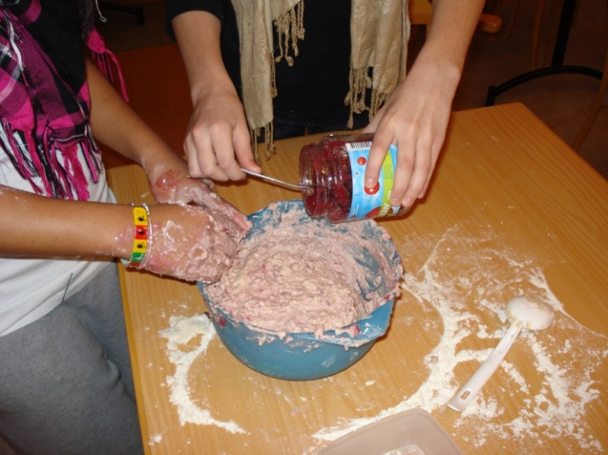



Add the filling that you wish.

Lingonberry, carrots or tomatoes!



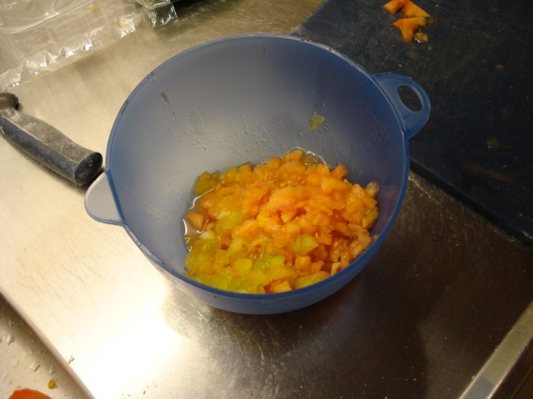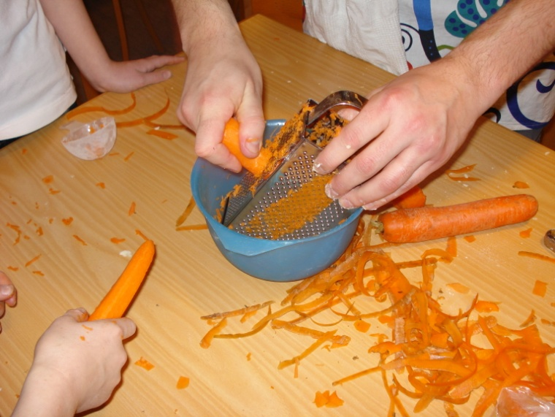

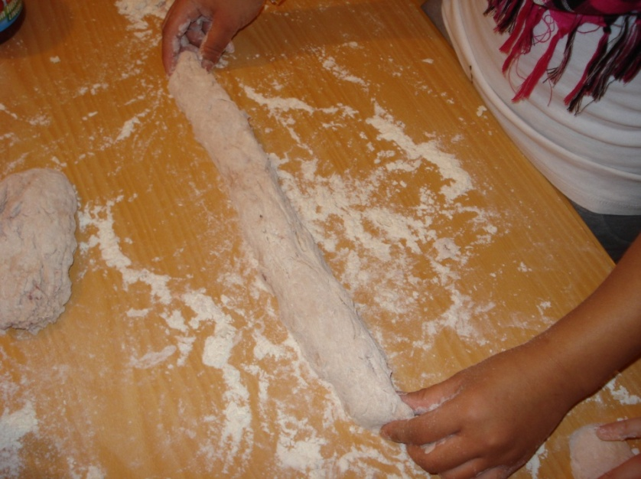



Divide the dough into 4 parts and roll the into lenghts.

Divide each roll into 8 pieces and roll them into 32 small breads.





Put them on a baking tin and cut a cross on the breads. Let them rise for 40 minutes.

Brush with beaten egg and sprinkle with poppy seeds.

Baket hem in the middle of the oven for 10-12 minutes in 250 degrees.



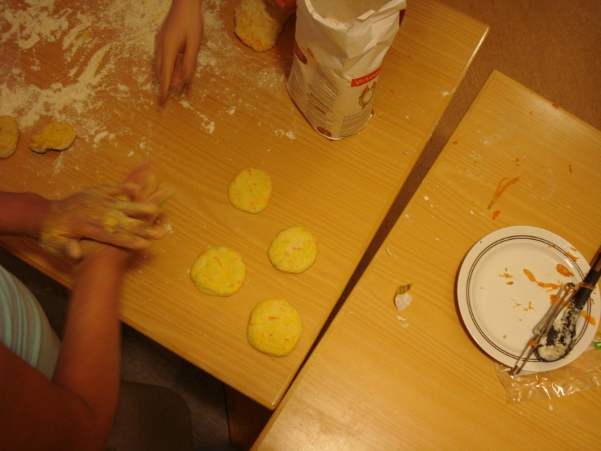

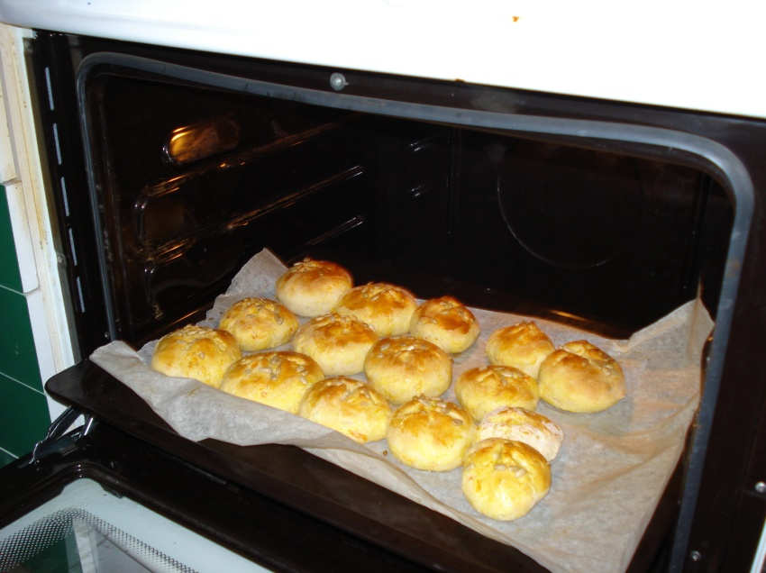



Varsågod!!!

Enjoy!

